**CS 628 Full-Stack Development II**

**HOS06B: Reverse Engineering Practice 2 for the Add Review Page**

July 19, 2020

12/29/2020 Updated by Min

School of Technology & Computing (STC)

City University of Seattle (CityU)

**Before You Start**

* The directory path shown in screenshots may be different from yours.
* Some steps are not explained in the tutorial**.** If you are not sure what to do:
  1. Consult the resources listed below.
  2. If you cannot solve the problem after a few tries, ask a TA for help.

**Resources**

* Holmes, S. & Harber, C. (2019). [Getting MEAN with Mongo, Express, Angular, and Node, Second Edition](https://login.proxy.cityu.edu/sso/skillport?context=148121). Manning Publications. (ISBN 9781617294754)
  + 4.5 Taking the Data out of the Views and Making Them Smarter
  + Appendix C: Dealing with All the Views
    - Listing C.3: addReview controller
    - Listing C.4: location-review-form.pug template
* Pug, <https://pugjs.org/api/getting-started.html>

**Course Concepts**

* Understand the roles of Views and Controllers.
* Apply the process of taking the data out of the Views
* Make the Views smarter if necessary.

**Activities**

* Preparing for a MEAN project environment
* **Reverse Engineering the Add Review page**
* Source Code Management and Deployment

**Preparing for a MEAN project environment**

1. Copy the “module06a” directory to the “module06b” one.
2. Open the “module06b” folder in the VSCode.  
   Close the “Welcome” window.  
   Open the terminal (Ctrl+`).
3. Test whether the application works correctly.  
   >>>npm start

|  |  |
| --- | --- |
| <http://localhost:3000> | <http://localhost:3000/about> |
| <http://localhost:3000/location/> | <http://localhost:3000/location/review/new> |

**Reverse Engineering the Add Review page**

1. Discover what data need to be moved to the about controller from <http://localhost:3000/location/review/new>  
     
   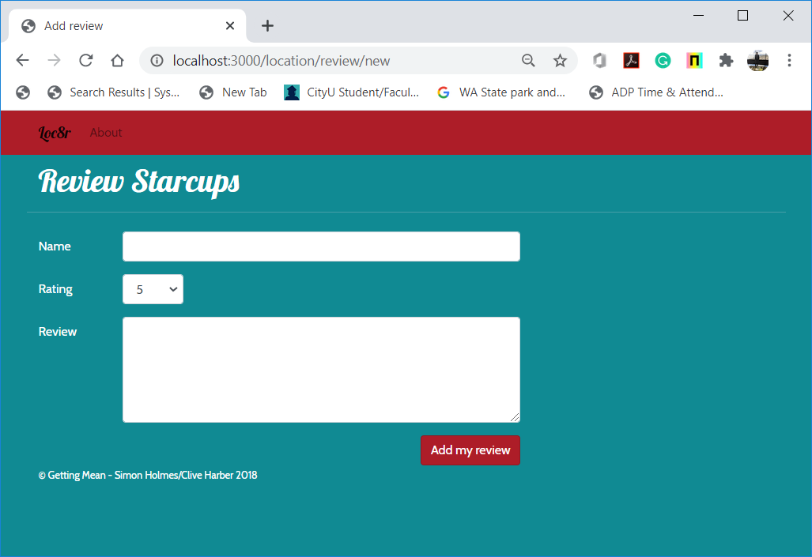
2. Look at the data in the view- location-review-form.pug.

extends layout

block content

*.row.banner*

*.col-12*

      h1 Review Starcups

*.row*

*.col-12.col-md-8*

      form(*action*="/location", *method*="get", *role*="form")

*.form-group.row*

          label*.col-10.col-sm-2.col-form-label*(*for*="name") Name

*.col-12.col-sm-10*

            input*#name.form-control*(*name*="name")

1. Create a structure for that data in the controller – addReview in locations.js.  
   >>>Before Change  
   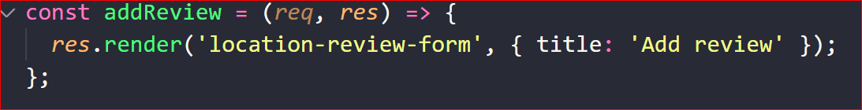  
     
   >>>After change  
   For full information, check Listing C.3: addReview controller

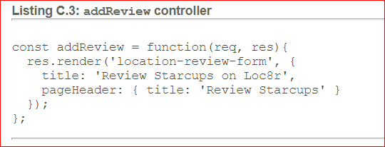

1. Replace the data in the view with references to the controller data - location-review-form.pug.  
   For full information, check Listing C.4: location-review-form.pug template

extends layout

block content

*.row.banner*

*.col-12*

      h1= pageHeader.title

*.row*

*.col-12.col-md-8*

      form(*action*="/location", *method*="get", *role*="form")

*.form-group.row*

          label*.col-10.col-sm-2.col-form-label*(*for*="name") Name

*.col-12.col-sm-10*

            input*#name.form-control*(*name*="name")

1. Test whether the application works correctly.  
   No interfaces were affected.  
   >>>npm start

|  |  |
| --- | --- |
| <http://localhost:3000> | <http://localhost:3000/about> |
| <http://localhost:3000/location/> | <http://localhost:3000/location/review/new> |

**Source Code Management and Deployment**

**Push your work to GitHub**

Run the following commands to push your work to the GitHub repository:

Open the terminal from the VSCode by hitting the control + ~ key and type the following command:

>>> git add .

>>> git commit -m “Submission for HOS06B --yourname”

>>> git push origin master

**Push your work to Heroku**

>>> git push heroku master

If you cannot remember your branch name, run the command “git status” to check.